# Rollover Image creation and final outcome

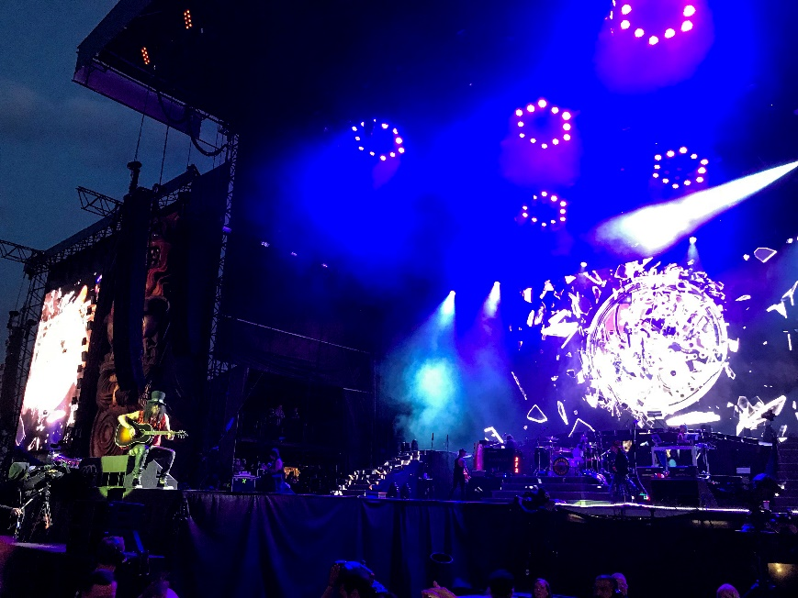 resolution: 4032 x 3024

camera: Iphone 7 Plus

F-stop: f/1.8

Exposure time: 1/17 sec.

ISO speed: ISO-80

Flash: No

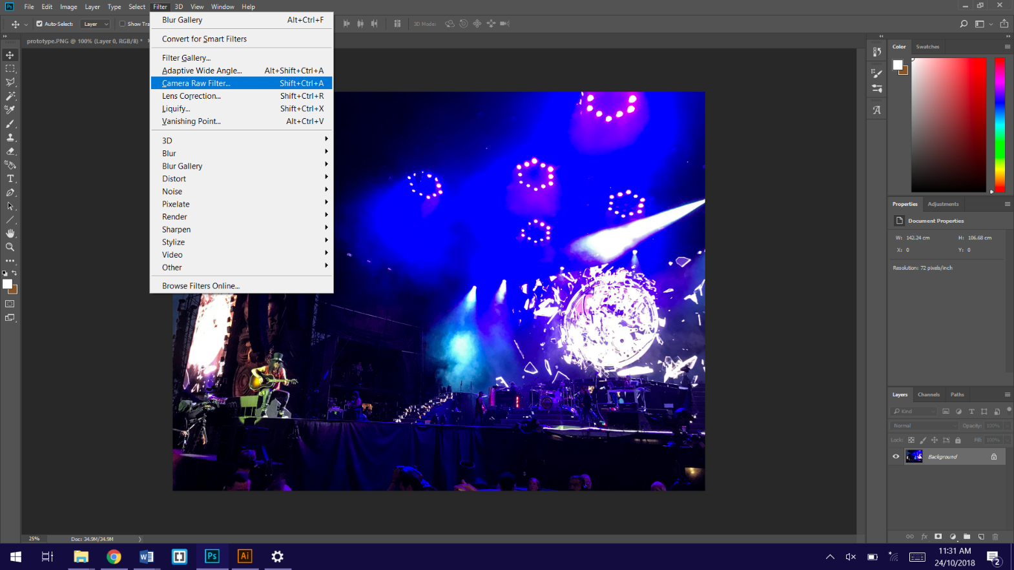here I am selecting camera raw filter. This allows me to adjust nearly all the settings of the original image.

below we can see it allows me to adjust settings such as contrast, exposure, clarity, vibrance, etc. I changed these to make the colours stand out more, but I also reduced the contrast so that more detail could be seen on the image as originally it was over exposed and had a lot of detail lost.

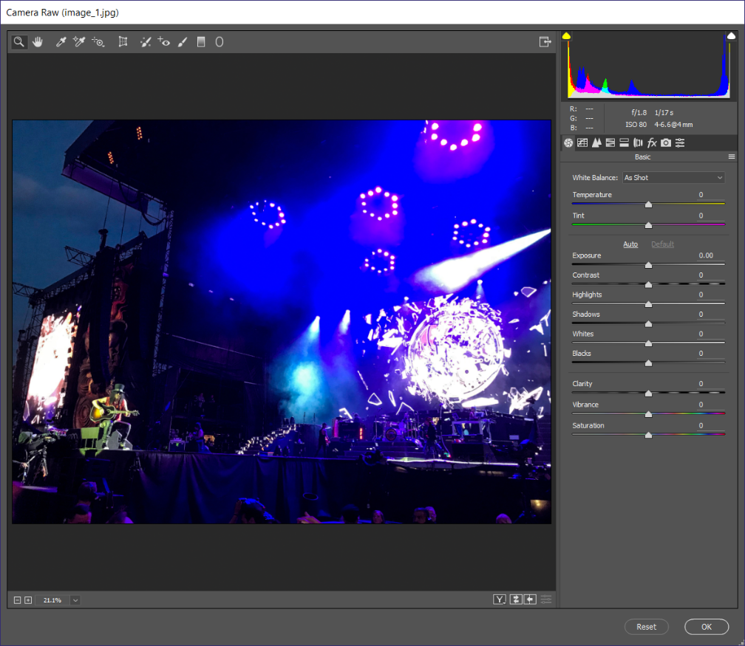

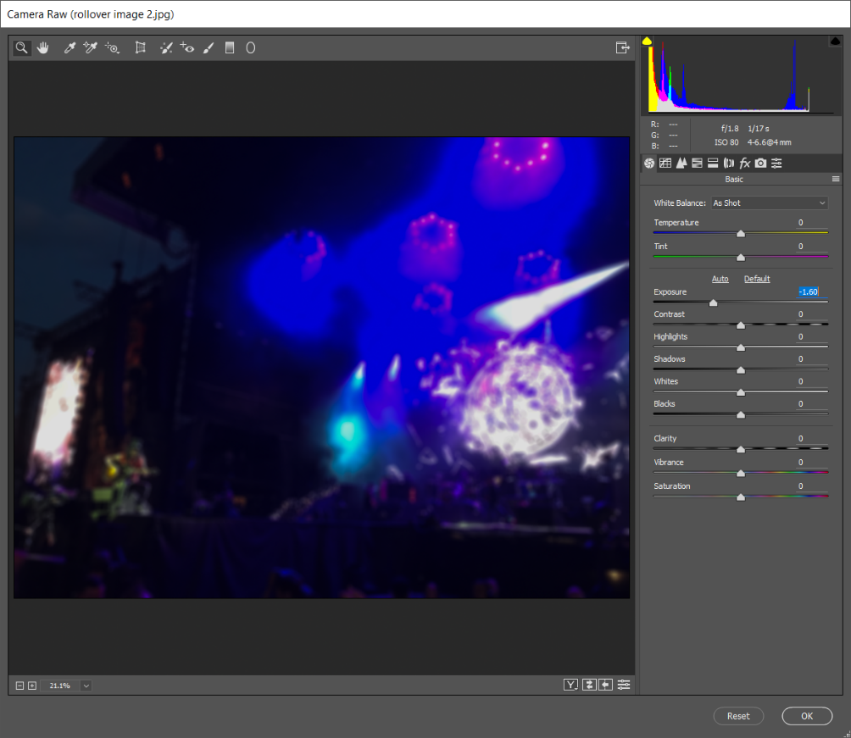

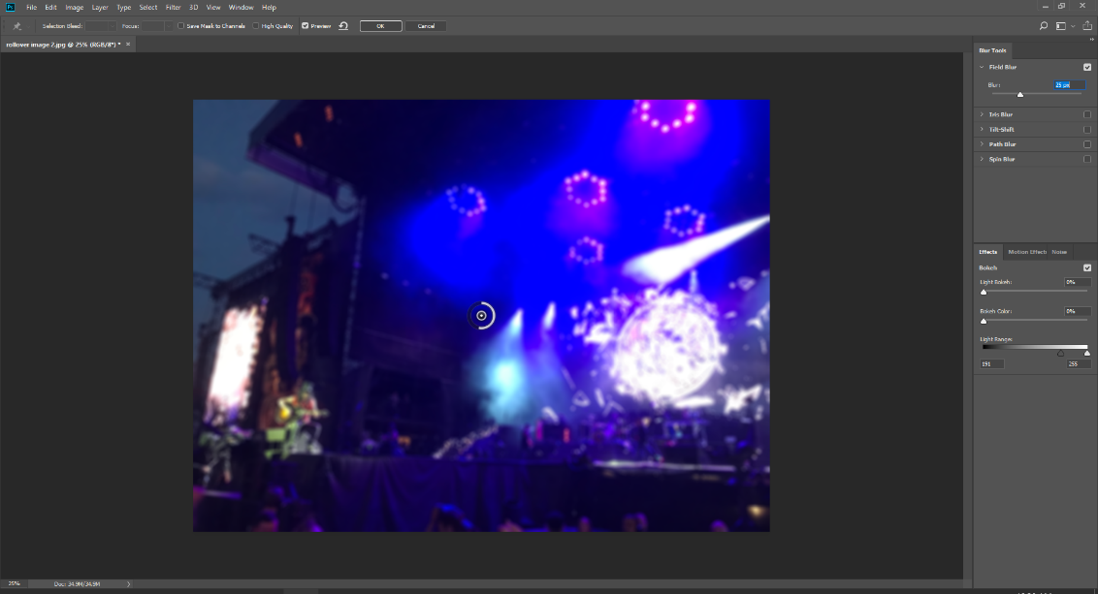in this screenshot I am adjusting the blur on the image. to apply the blur, I went to filter at the top and selected field blur. This then gave me a slider which allowed me to select the amount of blur I wanted on the image. the reason I am applying a blur to this particular image is because I wanted to have a transition from the original image to the image with the text over it, which meant I needed to add a blur to make the text easier to read but also to make the transition look smoother. I also think that having the text over a blurred background looks better than over a sharp background.